Hi so we are going to discuss about another loop statement. That is for in loop statement. You may wonder why I haven’t discussed about for in loop in simultaneously with other for loop.

The reason is we must have an idea about objects in java scripts.

Ok lets’ go to the lesson.

This loop is go through the object properties. So this is very useful loop.

The syntax is,

**for(variablename in object){  
 statement   
}**

So let’s see an example.

This prints the web browser’s Navigator object.

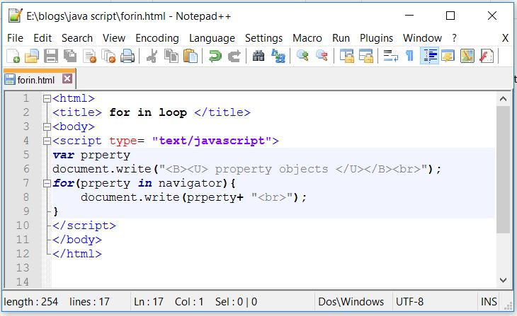

Figure 1

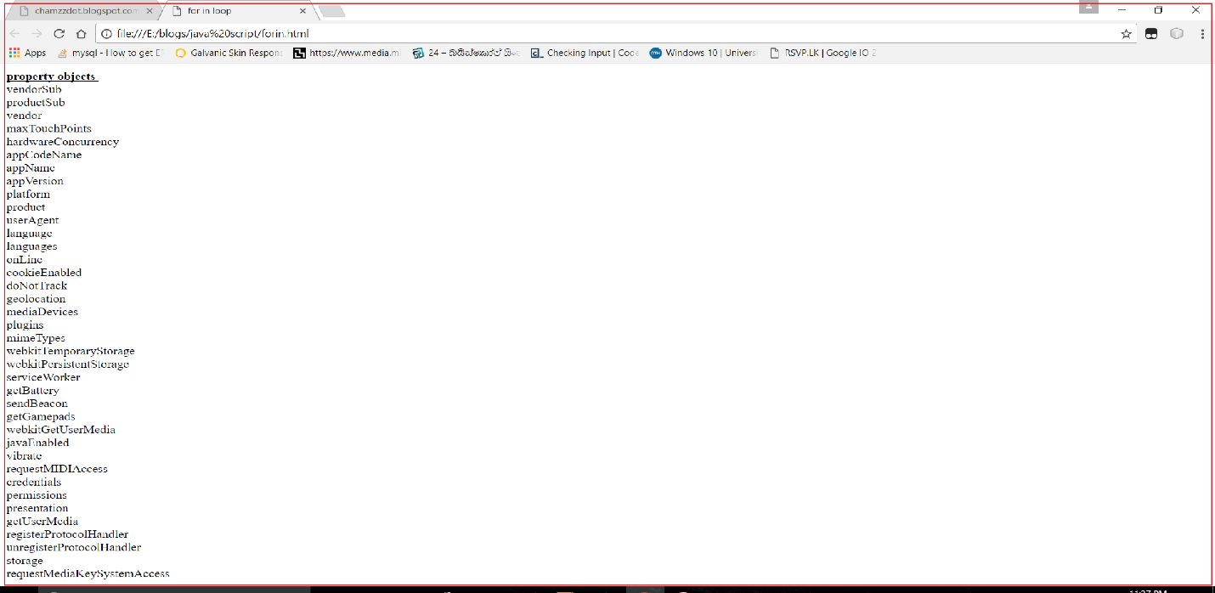

Figure 2

Let’s try with different object.

**<script>**

**function myFunction() {**

**var me = {fname:"Chamini", lname:"Prashakthi"};**

**var word = "";**

**var x;**

**for (x in me) {**

**word += me[x] + " ";**

**}**

**document.getElementById("demo").innerHTML = word;**

**}**

**</script>**

This will produce output as : Chamini Prashakthi